# LAB REPORT

# Lab 3: Control Design Using the Root Locus

# Lab Date: November 26, 2019

# Submission Date: December 2, 2019

# Prelab: 1 marks

# Lab Report: 4 marks

# Lab Work: 5 marks

|  |  |
| --- | --- |
| Name | Student Number |
| Pratyush Menon | 1004282661 |
| Saminul Islam Samin | 1004511833 |
|  |  |

## 4.1 Identification of model parameters

(0.25 mark) Estimated parameters are: $a=1.55$, $b=10$

## 4.2.1 Controller design using Matlab, Part 1

(0.25 mark) Root locus plot when TI = 1.

Using the plot, prove that there doesn’t exist K>0 such that the closed-loop system has two poles on the real axis with real part<-20.

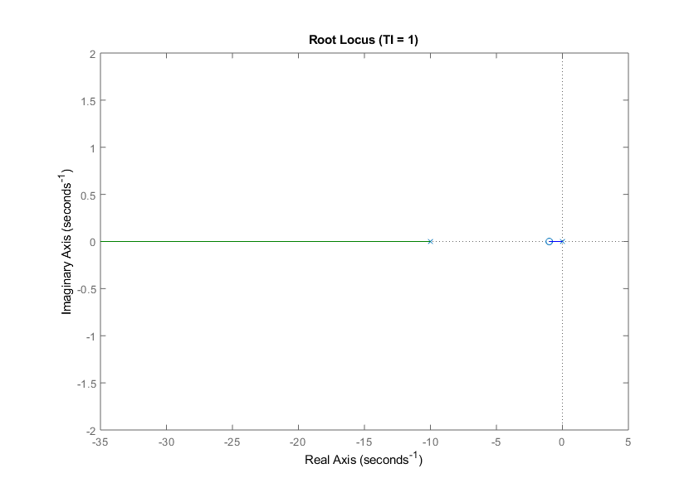

The green line represents the possible values for one of the poles, and the blue line represents possible values for the other pole (as the gain is varied). We can see that the values for the first pole (on the green line) extend from around -10 till negative infinity, while the values for the other pole can only be in the range from 0 to around -2. Thus, while the first pole can have a value less than -20, the second pole can never reach that value for any value of the gain.

(0.25 mark) Value of TI and K for which the closed-loop system has two poles at S = -20,

$T_{I}=0.075$, $K=19.4$

(0.25 mark) Root locus plot for the value of TI you just found.

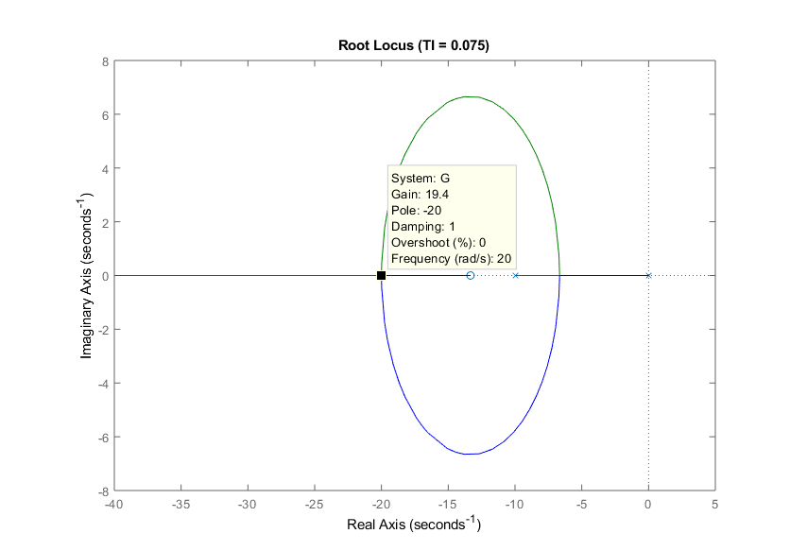

## 4.2.2 Controller design using Matlab, Part 2

(0.25 mark) Plot showing one period of the simulation output (with proper labels).

What is the estimated value of the settling time: sec

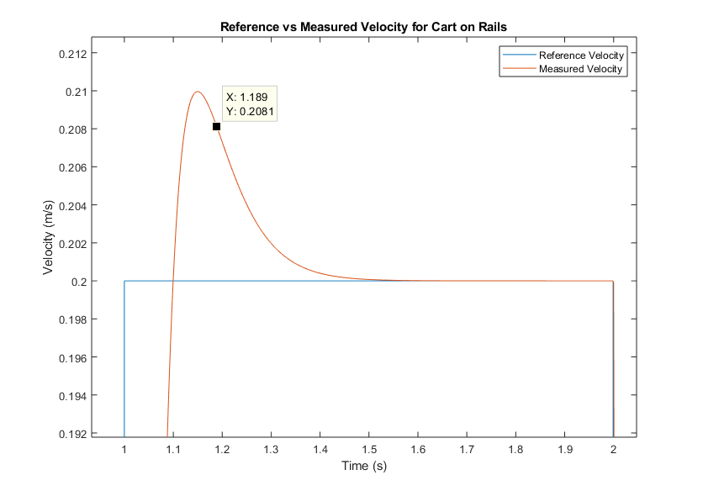

(0.25 mark) Plot showing the control input voltage Vm(t) (with proper labels).

What is the peak value of Vm(t) ?

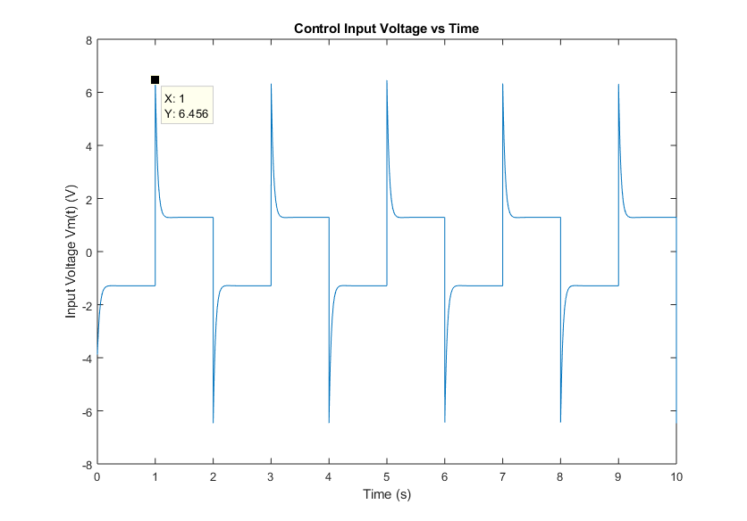

The peak value of $V_{m}(t)$ is 6.456V.

## 4.2.3 Controller design using Matlab, Part3

(0.25 mark) Value of TI and K for the more aggressive controller (S = -30)

$T_{I}=0.0552$, $K=32.6$

(0.25 mark) Plot showing one period of the simulation output (with proper labels).

What is the estimated value of the settling time: sec

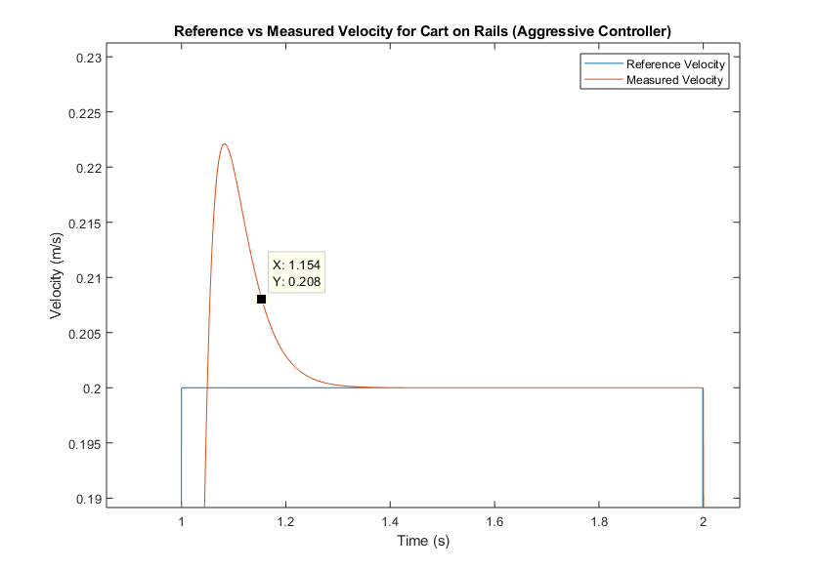

(0.25 mark) Plot showing the control input voltage Vm(t) (with proper labels).

What is the peak value of Vm(t) ?

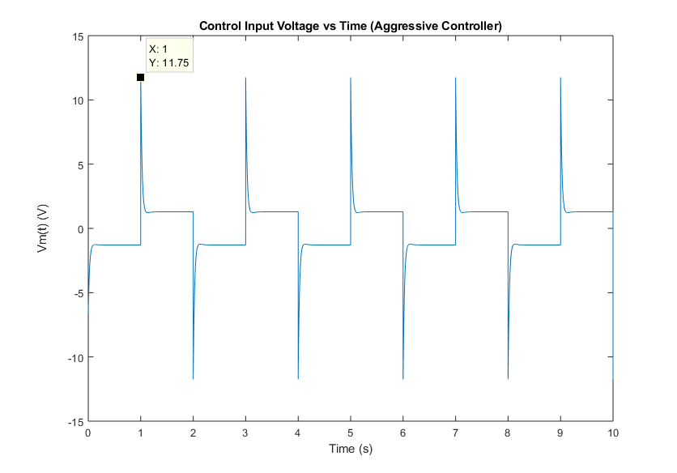

The peak value of $V_{m}(t)$ is 11.75V.

(0.75 mark) Compare the performance of the two controller you designed earlier.

How do settling time and overshoots compare? How about maximum value of Vm(t)?

Which controller is best suited to meet the specifications?

What is the cause of the differences between the two controllers?

The aggressive controller has a lower settling time, but higher overshoot. However, both controllers are well within the desired specifications. The maximum value for $V_{m}(t)$ is a lot larger on the aggressive controller than the normal controller.

Overall, although the aggressive controller offers lower settling times, the normal controller is better suited to meet the specifications as it offers larger margin for error in terms of the peak value for $V_{m}(t)$. The aggressive controller draws 11.75V at its peak, which is exactly the maximum that the Arduino can provide. However, in the case of manufacturing and/or measuring errors, this value may not be exact, so there may be cases where the aggressive controller gets bottlenecked by the Arduino. On the other hand, the normal controller draws much less voltage from the Arduino, so it doesn’t have those issues, while also successfully fulfilling all the other desired specifications.

The aggressive controller has poles close to $s=-30$ while the normal controller has poles around $s=-20$ which means that the aggressive controller will have a faster decaying exponential compared to the normal controller resulting in a lower settling time as seen in the experiment. However, in order to get poles at those locations, the aggressive controller required a greater gain, K, compared to the normal controller resulting in a greater overshoot value and greater peak value of $V_{m}(t)$.

## 4.3 Controller Implementation

(0.5 mark) Normal controller, with no disturbance:

Plot showing actual cart speed V(t) and reference r(t) (with proper labels).

What is the estimated value of the settling time: $T_{s}=0.18$ sec

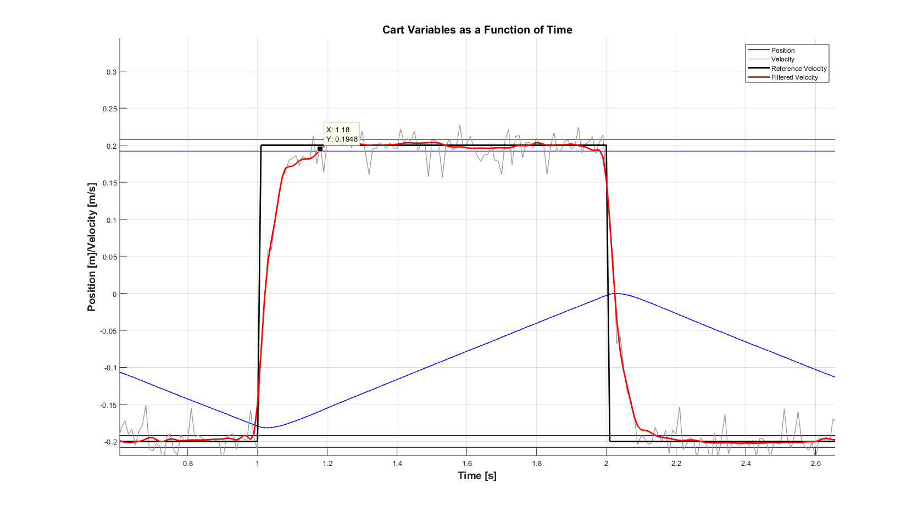

(0.5 mark) Normal controller, when cart is tilted:

Plot showing actual cart speed V(t) and reference r(t) (with proper labels).

What is the estimated value of the settling time: $T_{s}=0.19$ sec

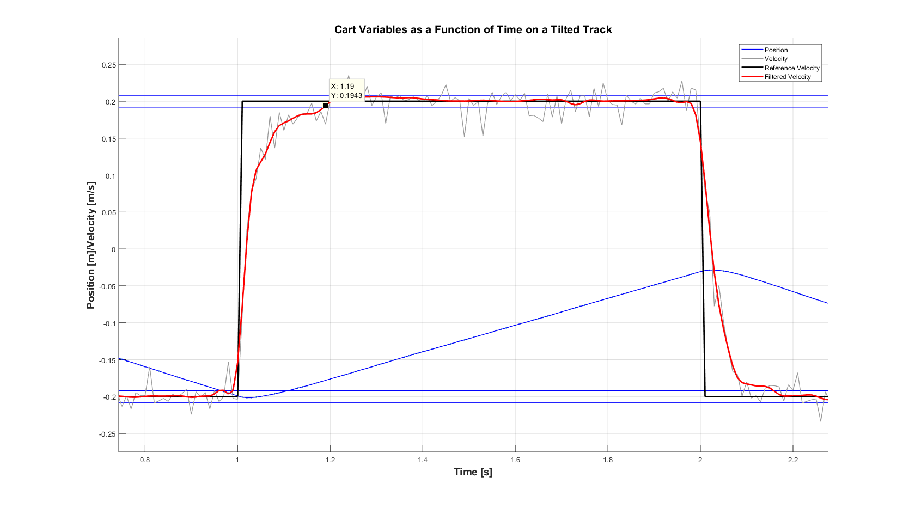

(0.5 mark) Aggressive controller, with no disturbance:

Plot showing actual cart speed V(t) and reference r(t) (with proper labels).

What is the estimated value of the settling time: $T_{s}=0.07$ sec

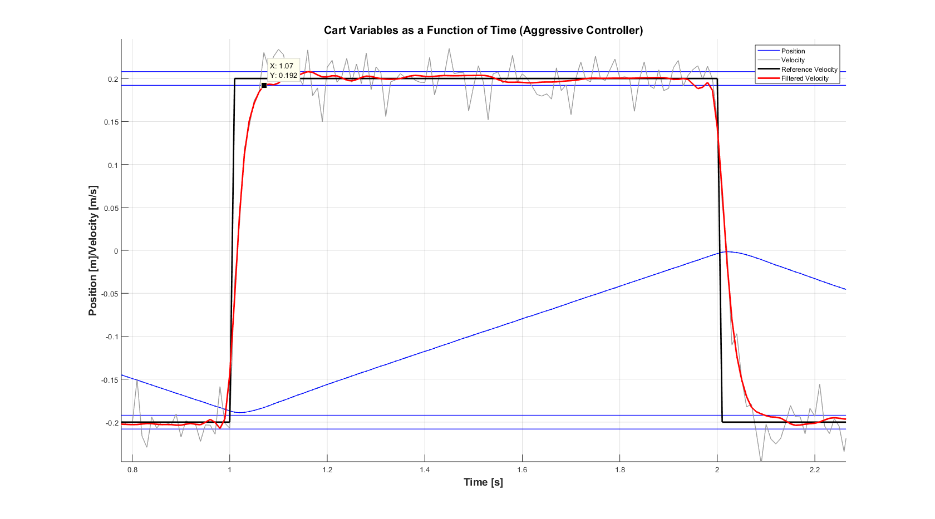

(0.5 mark) Aggressive controller, when cart is tilted:

Plot showing actual cart speed V(t) and reference r(t) (with proper labels).

What is the estimated value of the settling time: sec

